**RANK WISE CHANNEL**

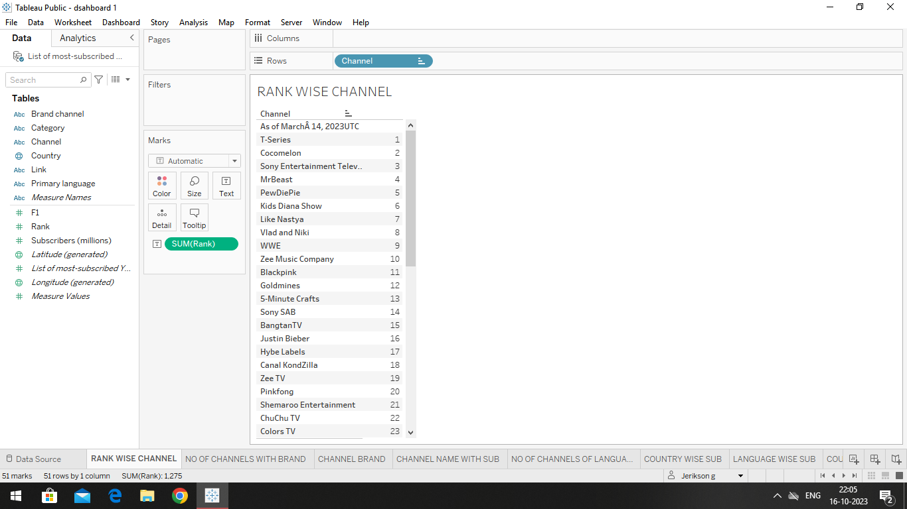

**NO.OF.CHANNELS WITH BRAND** 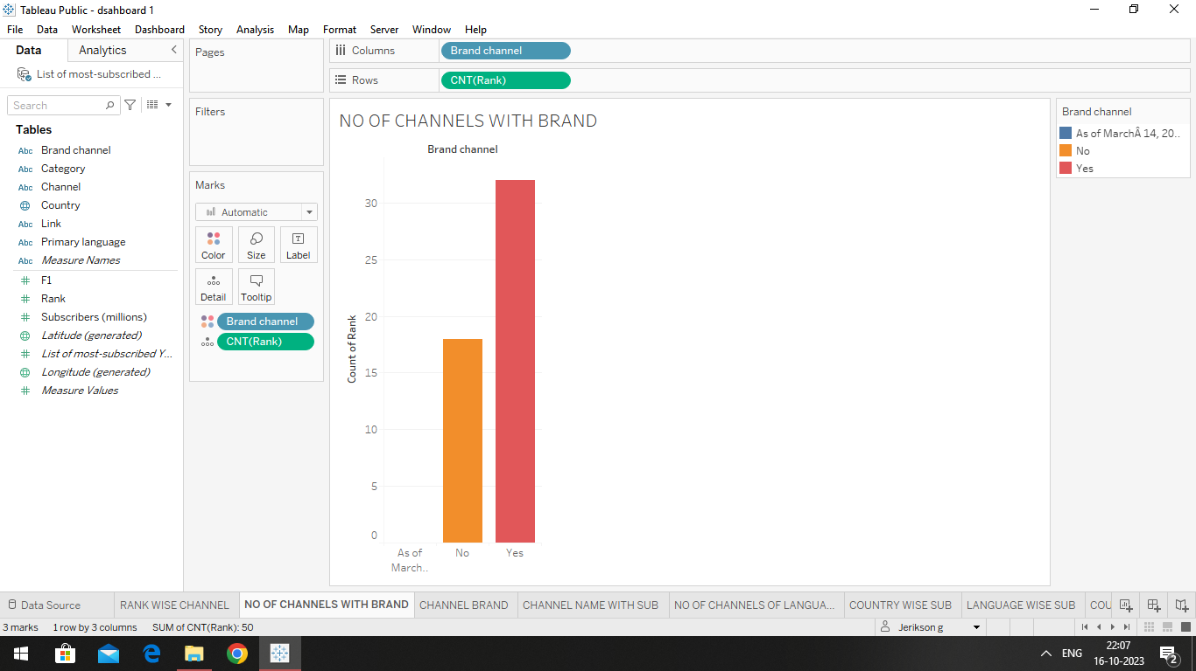

**CHANNEL BRAND EXPLANATION**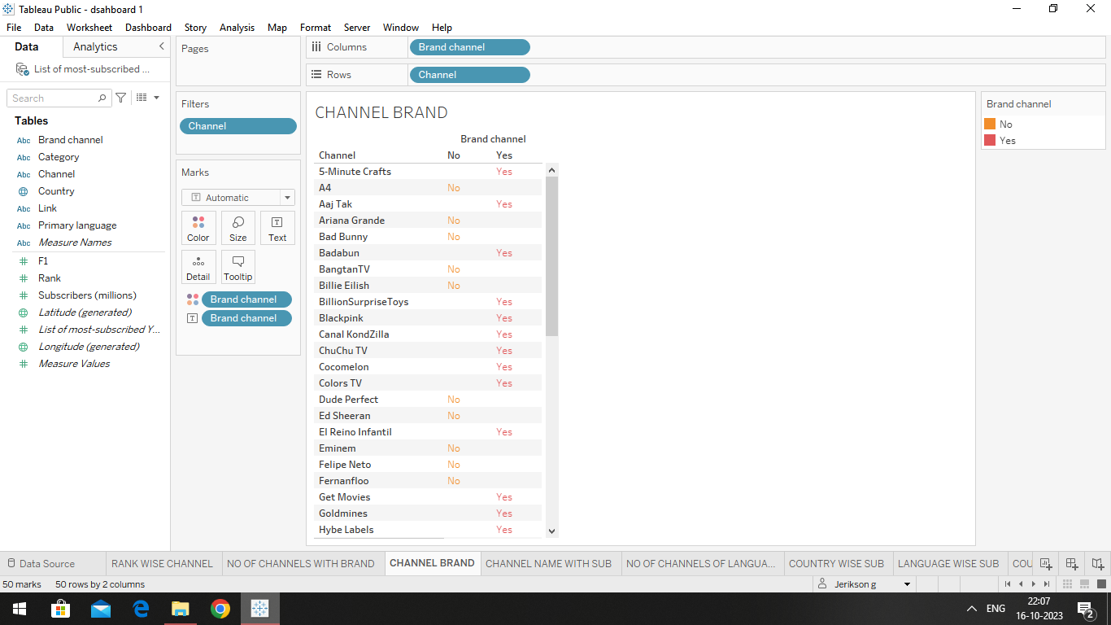

**CHANNEL NAME WITH SUBSCRIBERS**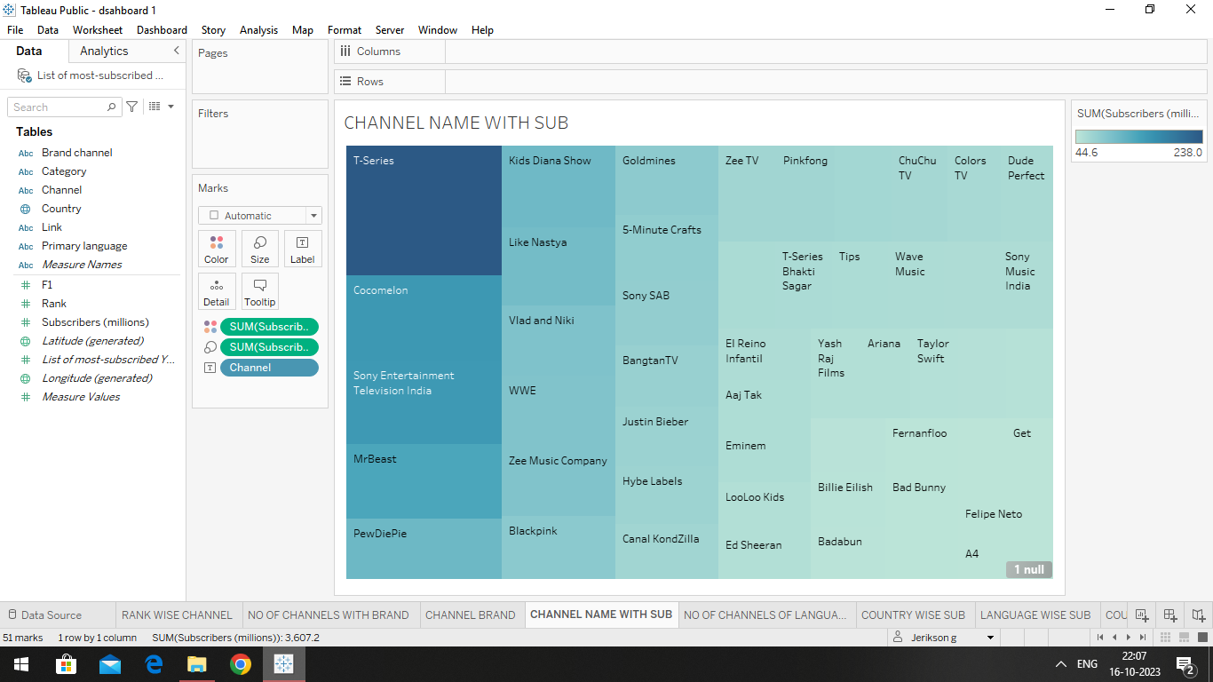

**NO.OF.CHANNELS FOR PARTICULAR CHANNELS**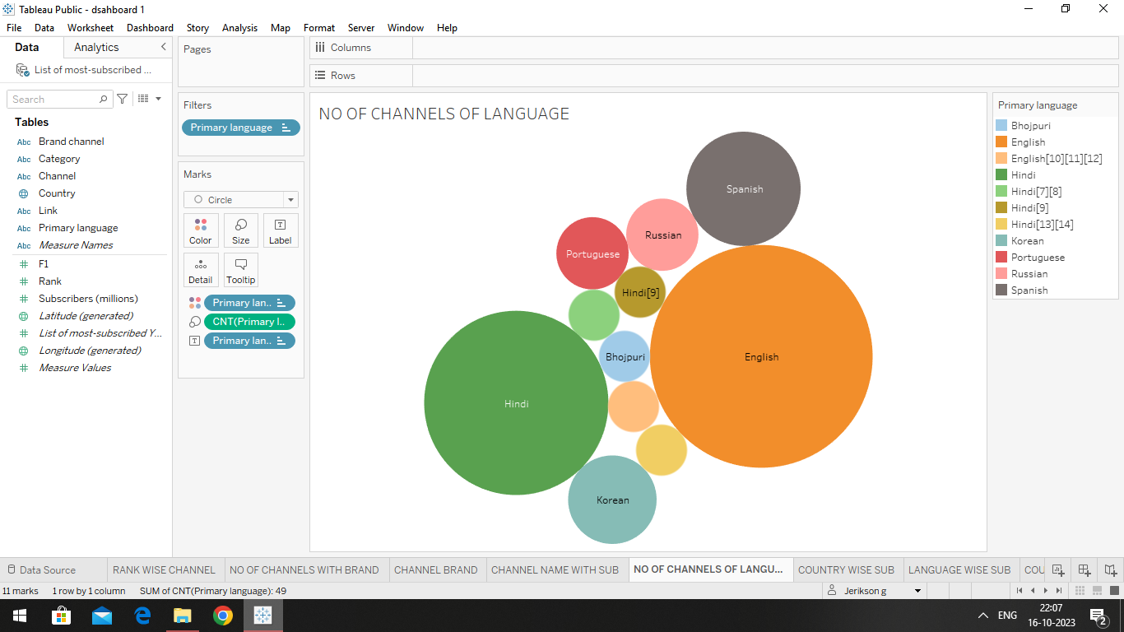

**COUNTRY WISE SUBSCRIBERS**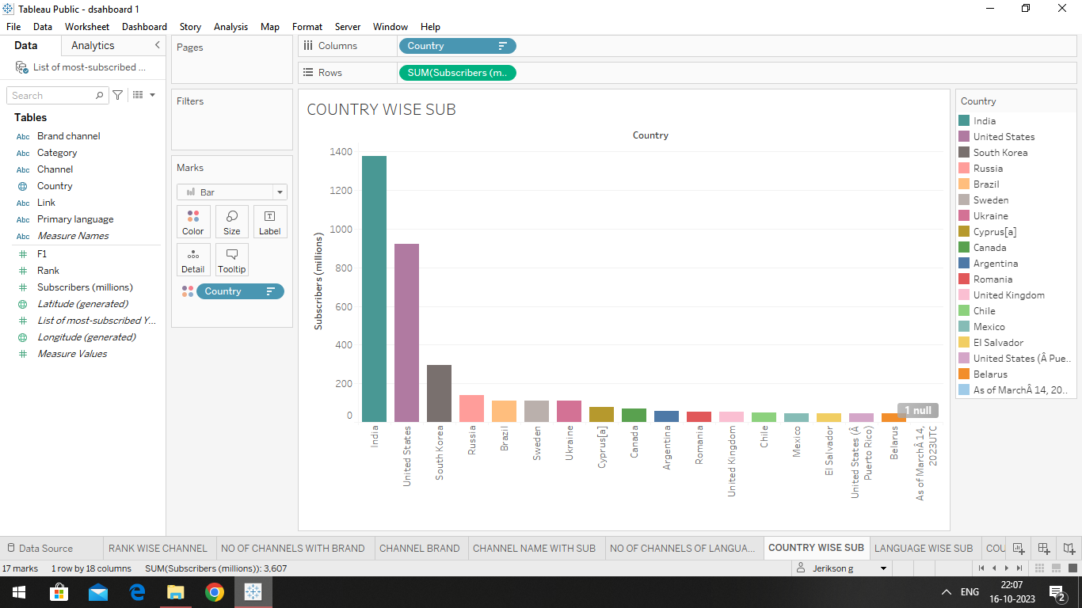

**LANGUAGE WISE SUBSCRIBERS**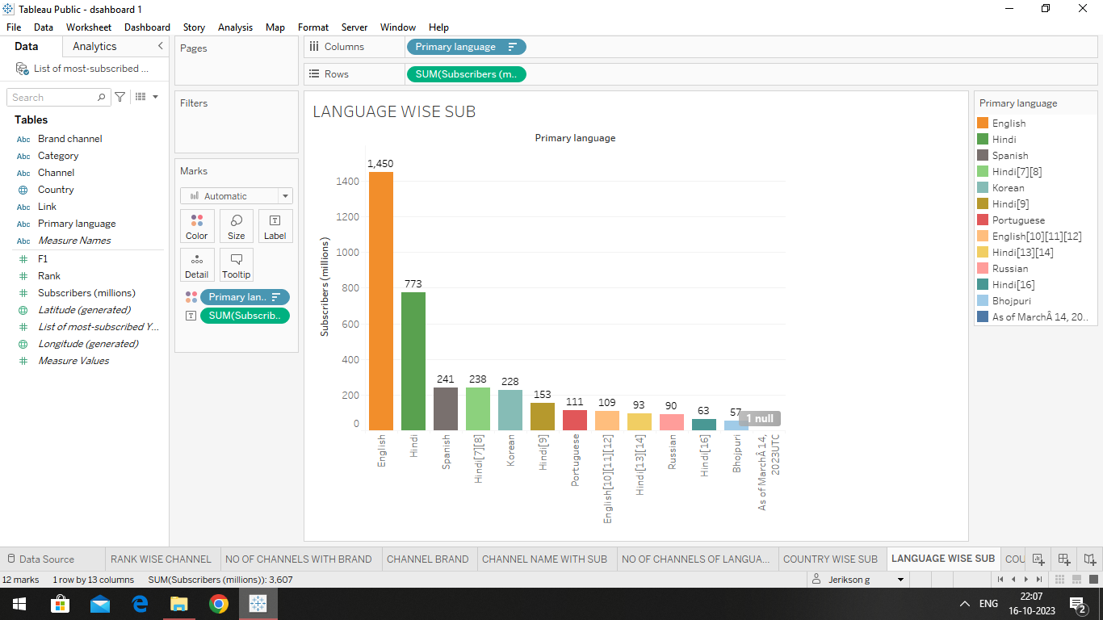

**COUNTRY WISE CHANNEL**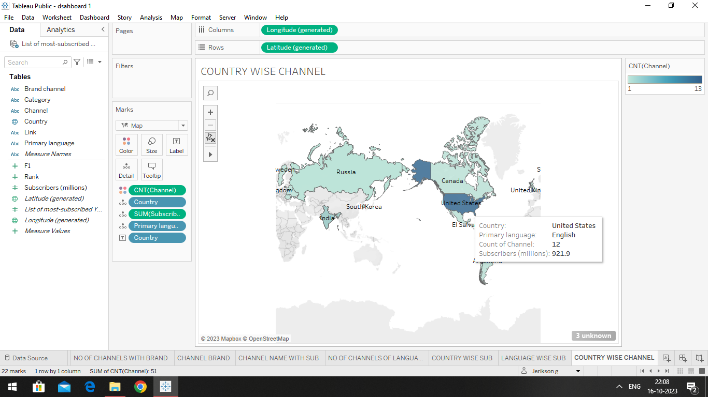

**MAP**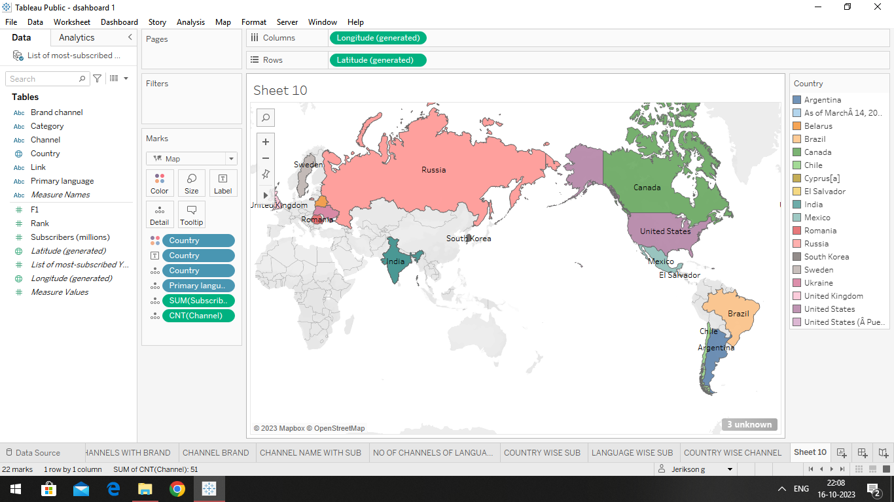

**DASHBOARD 1**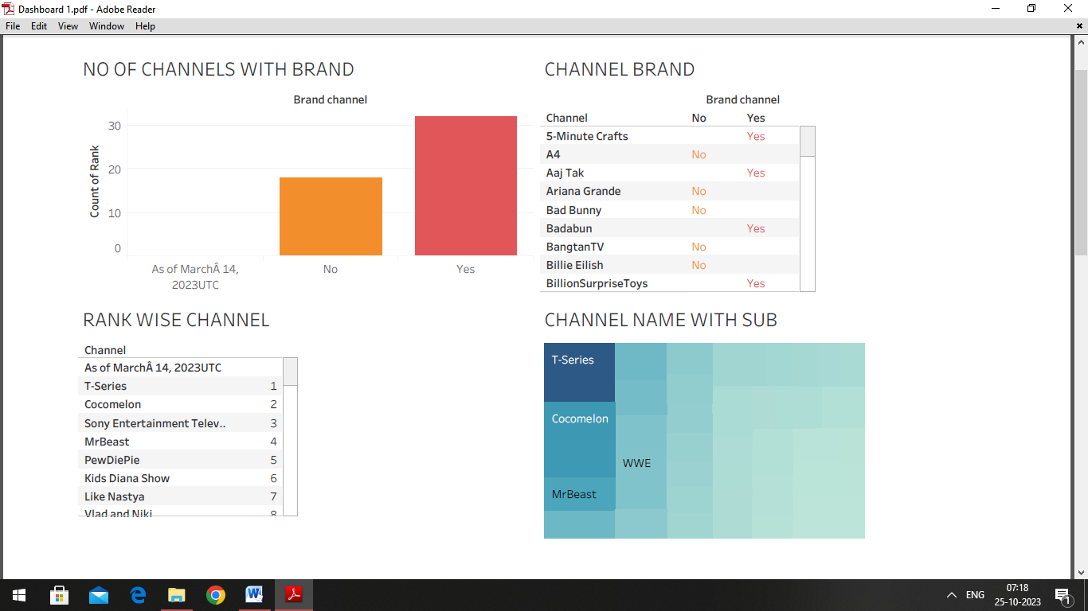

**DASHBOARD 2**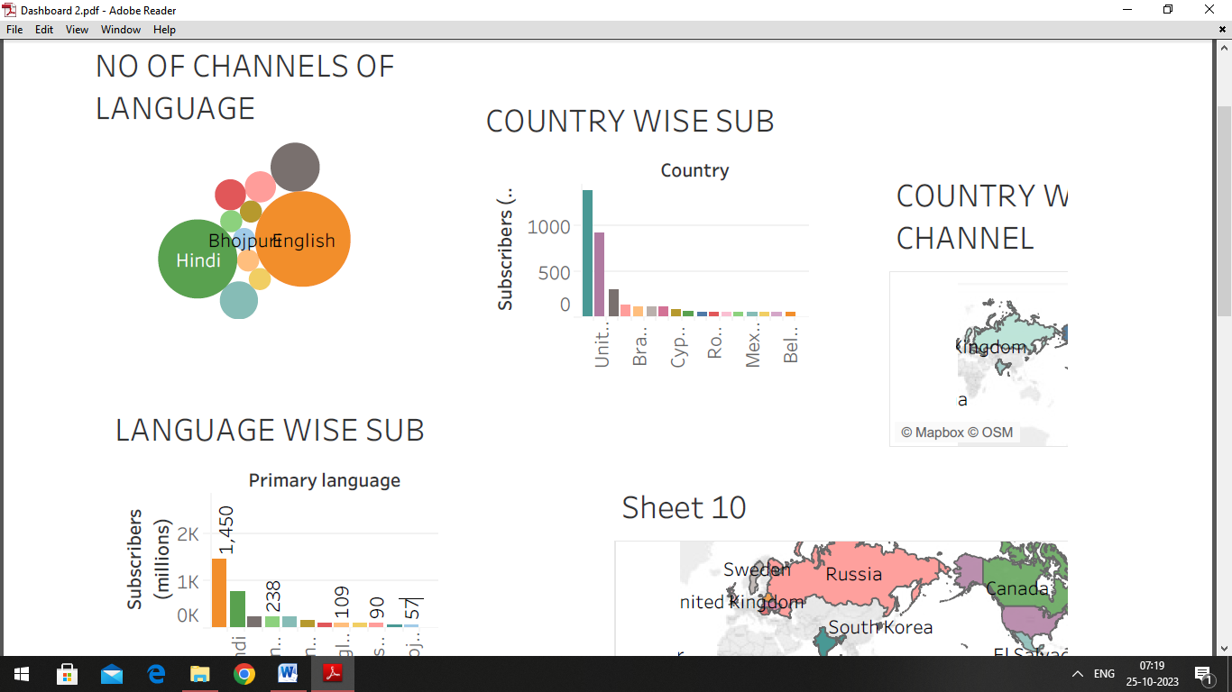

**STORY**